import keys

once the automation oage opens

inspect

that small icon to get d=individual details

search for id of searchbar

and type driver.findElement(By.*id*("APjFqb")).sendKeys("Java",Keys.***ENTER***);

then go to that java oracle thingy and right click on the blu thing(right) copy full xpath

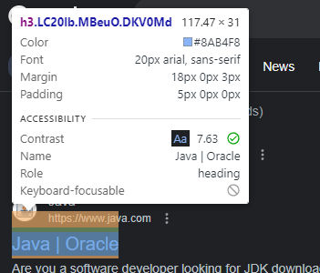

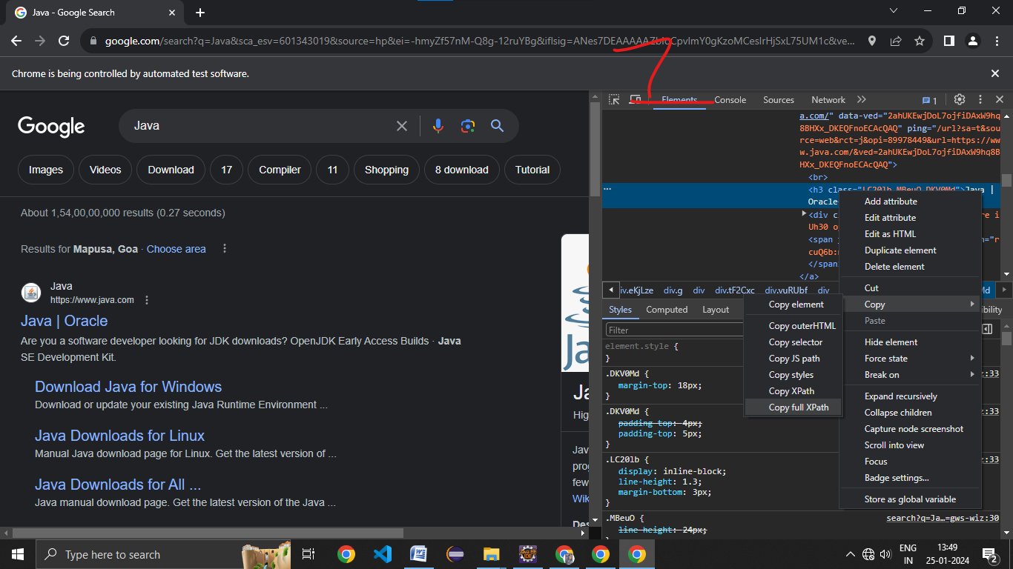

Type to visit the link driver.findElement(By.*xpath*("/html/body/div[5]/div/div[11]/div[1]/div[2]/div[2]/div/div/div[1]/div/div/div/div/div/div/div/div[1]/div/span/a/h3")).click();

Create a class to automate the login to xavier’s internet portal